**Atmel ATmega328 Test Circuit Diagram**

The ATmega88 through ATmega328 microcontrollers are said by Atmel to be the upgrades from the very popular ATmega8. They are pin compatible, but not functionally compatible. The ATmega328 has 32kB of flash, where the ATmega8 has 8kB. Other differences are in the timers, additional SRAM and EEPROM, the addition of pin change interrupts, and a divide by 8 prescaler for the system clock.

The schematic below shows the Atmel ATmega328 circuit as it was built on the test board. The power supply is common and is shared between all of the microcontrollers on the board. The ATmega328 is in a minimal circuit. It is using its internal 8 MHz RC oscillator (divided by 8). With the ATmega328 I needed to both burn a bootloader and download Arduino sketches. The bootloader is programmed using the ISP programming connector, and the Arduino sketches are uploaded via the 6-pin header. Be aware that programming the Arduino bootloader into the ATmega88, ATmega168, or ATmega328 micrcontroller will change the clock fuses, requiring the addition of an external crystal. The crystal shown on the schematic is only *required* when the ATmega328 is going to be used as an Arduino, although it may be desired in any real world application. I typically run them at 16 MHz, but they will run as high as 20 MHz.

There are schematics and an ExpressPCB design file for a full [28-pin AVR development board](http://avrprogrammers.com/proj_dev28.php) that supports the ATmega8, ATmega48, ATmega88, ATmega168, and ATmega328 (the ATmega328 pinout is the same as these others).

**Projects featuring the ATmega328**

* [SIRC IR remote receiver](http://avrprogrammers.com/proj_sirc_1.php)
* [28-pin AVR development board](http://avrprogrammers.com/proj_dev28.php)

**Atmel ATmega328 Datasheet**

Here you can find the current [Atmel ATmega328 datasheet](http://www.atmel.com/Images/Atmel-8271-8-bit-AVR-Microcontroller-ATmega48A-48PA-88A-88PA-168A-168PA-328-328P_datasheet.pdf)

**Atmel ATmega328 Pinout**

[[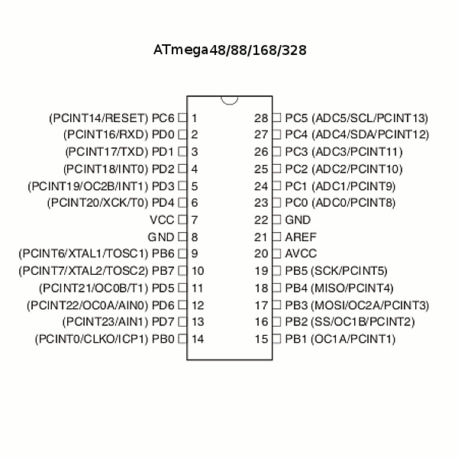](http://avrprogrammers.com/images/atmegaxx8.gif)](http://avrprogrammers.com/images/atmegaxx8.gif)

[Atmel ATmega328 Pinout](http://avrprogrammers.com/images/atmegaxx8.gif)

**Schematic Diagram**

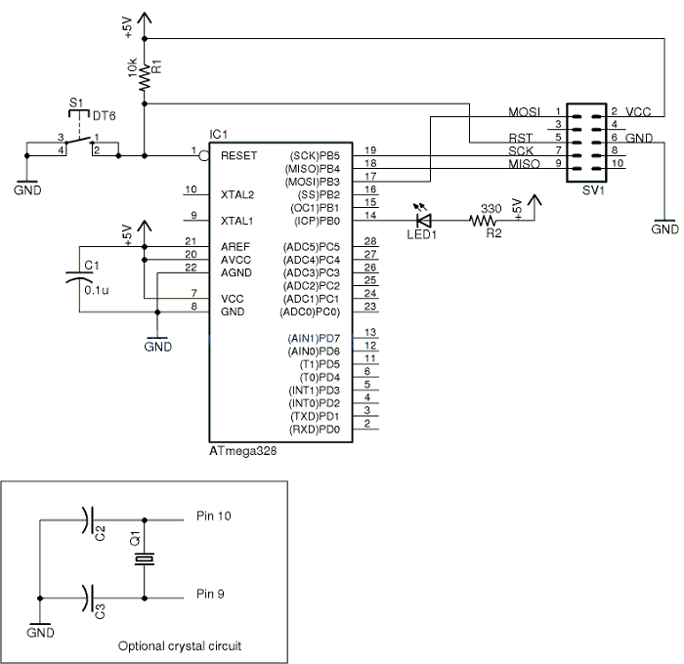

**Parts**

* IC1 Atmel ATmega328 MCU
* C1 0.1 uF ceramic capacitor
* C2,C3 22 pF ceramic capacitor
* Q1 16 MHz crystal
* R1 10k 5% 1/4W resistor
* R2 330 5% 1/4W resistor
* LED1 5mm red LED
* S1 Momentary pushbutton switch
* SV1 10 pin shielded header or dual row header
* X1 6 pin Molex KK100 or single row header
* Not shown
  + Perfboard
  + 28-pin socket
  + Power supply

**Notes**

* This board works with the ATmega8, ATmega48, ATmega88, ATmega168, and ATmega328
* The ATmega8 is not code compatible with the others.

The schematic below is for a more comprehensive [28-pin AVR board](http://avrprogrammers.com/proj_dev28.php) that can be found elsewhere on the site. It has switches, LEDs, pots, an ISP connector and a serial TTL upload connector. The upload connector is compatible with the FTDI TTL-232R-5V cable as well. It has been tested with ATmega88, ATmega168, and ATmega328 microcontrollers, but should work with ATmega8 and ATmega48 as well, although the ATmega48 does not support bootloading.

[[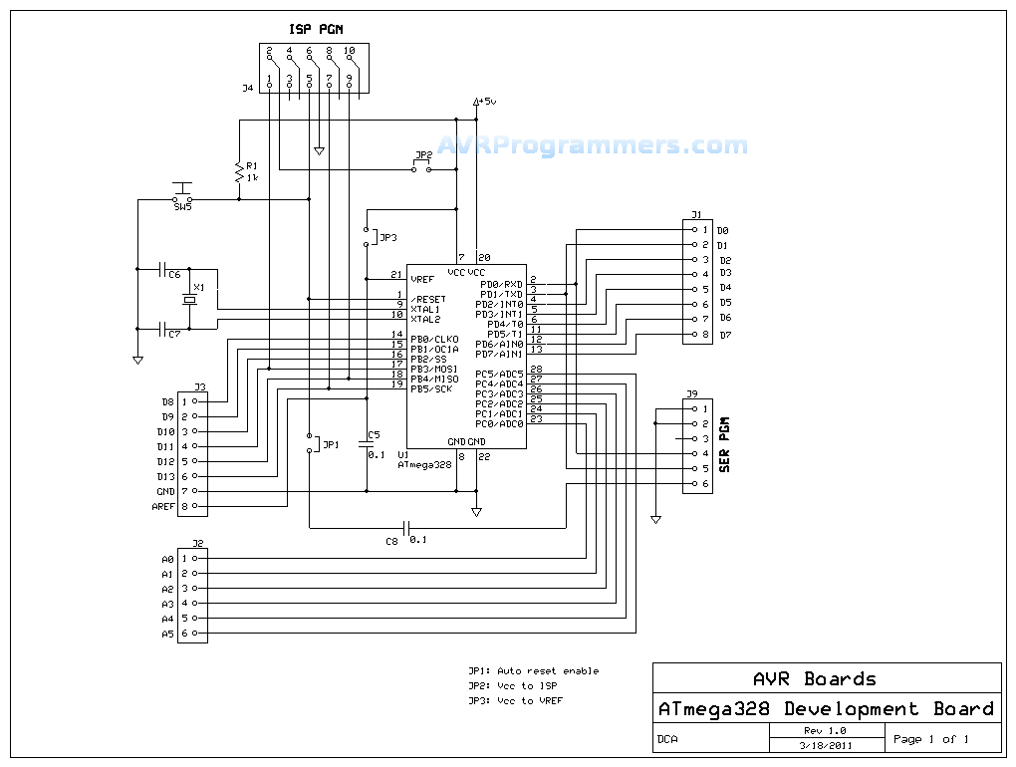](http://avrprogrammers.com/images/dev28a1sch.png)](http://avrprogrammers.com/images/dev28a1sch.png)

[28-pin ATmega Microcontroller Schematic](http://avrprogrammers.com/images/dev28a1sch.png)

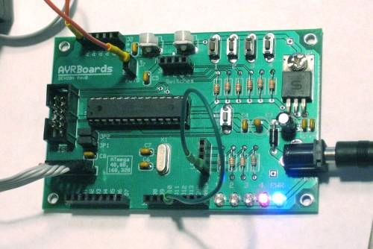

Uploading an Arduino sketch into an AVRBoards Dev28A with an ATmega328

**NOTE:** The ATmega48, ATmega88, ATmega168, and ATmega328 specs can all be found in the ATmega328 datasheet. The ATmega8, being a different part, has it's own datasheet.